Math 9 Multiplying/Dividing Polynomials: Row Partners Activity

Question List #1 | Answers (Should be the same for both sides) | Question List #2
$$(-2x^{2})(-18x^{2})$$ | $$36x^{4}$$ | $$(4x)(9x^{3})$$
$$(-6ab^{3})(8a^{4})$$ | $$-48a^{5}b^{3}$$ | $$(24a^{2}b^{2})(-2a^{3}b)$$
$$2(-3x+6)$$ | $$-6x+12$$ | $$-3(2x-4)$$
$$5y(-y+3)$$ | $$-5y^{2}+15y$$ | $$-y(5y-15)$$
$$-2t^{2}(-9-3t^{2})$$ | $$6t^{4}+18t^{2}$$ | $$-3t^{2}(-2t^{2}-6)$$
$$-2x(2x^{2}-4x+12)$$ | $$-4x^{3}+8x^{2}-24x$$ | $$4x(-x^{2}+2x-6)$$
$$-7xy(-6y+18x)$$ | $$-126x^{2}y+42xy^{2}$$ | $$6xy(-21x+7y)$$
$$\frac{6x^{3}}{3x}$$ | $$2x^{2}$$ | $$\frac{4x^{4}}{2x^{2}}$$
$$\frac{15x^{4}y^{2}}{3xy}$$ | $$5x^{3}y$$ | $$\frac{10x^{4}y^{3}}{2xy^{2}}$$
$$\frac{3x-6}{3}$$ | $$x-2$$ | $$\frac{6x-12}{6}$$
$$\frac{8y^{2}-4y}{-2y}$$ | $$-4y+2$$ | $$\frac{12y^{2}-6y}{-3y}$$
$$\frac{3x^{4}+18x^{3}+9x^{2}}{3x^{2}}$$ | $$x^{2}+6x+3$$ | $$\frac{2x^{4}+12x^{3}+6x^{2}}{2x^{2}}$$
$$-2(3x^{2}-2x+1)-\frac{9x^{2}+6x-3}{3}$$ | $$-9x^{2}+2x-1$$ | $$\frac{8x^{2}+6x+2}{-2}-5x(x-1)$$
Find the height  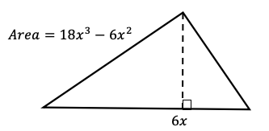 | $$6x^{2}-2x$$ | Find the height  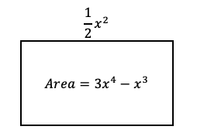
Find the surface area of the box  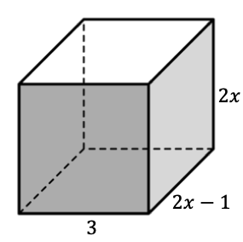 | $$8x^{2}+20x-6$$ | Find the surface area of the box  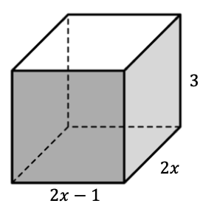

Math 9 Multiplying/Dividing Polynomials: Row Partners Activity

Question List #1 | Answers (Should be the same for both sides) | Question List #2
$$(-2x^{2})(-18x^{2})$$ |  | $$(4x)(9x^{3})$$
$$(-6ab^{3})(8a^{4})$$ |  | $$(24a^{2}b^{2})(-2a^{3}b)$$
$$2(-3x+6)$$ |  | $$-3(2x-4)$$
$$5y(-y+3)$$ |  | $$-y(5y-15)$$
$$-2t^{2}(-9-3t^{2})$$ |  | $$-3t^{2}(-2t^{2}-6)$$
$$-2x(2x^{2}-4x+12)$$ |  | $$4x(-x^{2}+2x-6)$$
$$-7xy(-6y+18x)$$ |  | $$6xy(-21x+7y)$$
$$\frac{6x^{3}}{3x}$$ |  | $$\frac{4x^{4}}{2x^{2}}$$
$$\frac{15x^{4}y^{2}}{3xy}$$ |  | $$\frac{10x^{4}y^{3}}{2xy^{2}}$$
$$\frac{3x-6}{3}$$ |  | $$\frac{6x-12}{6}$$
$$\frac{8y^{2}-4y}{-2y}$$ |  | $$\frac{12y^{2}-6y}{-3y}$$
$$\frac{3x^{4}+18x^{3}+9x^{2}}{3x^{2}}$$ |  | $$\frac{2x^{4}+12x^{3}+6x^{2}}{2x^{2}}$$
$$-2(3x^{2}-2x+1)-\frac{9x^{2}+6x-3}{3}$$ |  | $$\frac{8x^{2}+6x+2}{-2}-5x(x-1)$$
Find the height |  | Find the height
Find the surface area of the box |  | Find the surface area of the box

